Australian Defence Force veterans detail growing scourge of post-traumatic stress disorder
AM
By Rachael Brown
Updated 23 Apr 2014, 12:22pm
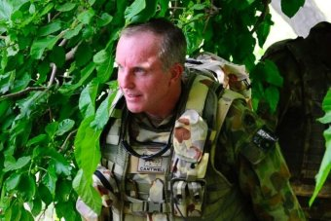PHOTO: Major General John Cantwell says statistics on PTSD show only the beginning of a major problem.
RELATED STORY: Number of soldiers committing suicide more than triples Afghan combat toll
MAP: Australia
As Australia prepares to mark Anzac Day commemorations, a former top commander is warning of a tidal wave of new post-traumatic stress disorder (PTSD) cases amongst returning veterans.
There has been a four-fold increase in PTSD cases since Australian troops first went to war in Afghanistan in 2001.
Some veterans have told the ABC the health system will not cope - and say some of their comrades will be reluctant or unable to admit that they have PTSD.
Many do not report their symptoms, and as the ABC reported yesterday, their subsequent unravelling has resulted in a suicide toll three times that of Australia's combat losses in Afghanistan.
The ADF and Department of Veterans' Affairs (DVA) assert they have made huge inroads reducing the stigma of PTSD, but many soldiers and veterans say the reality is very different.
Media player: "Space" to play, "M" to mute, "left" and "right" to seek.
00:00
00:00
AUDIO: Major General Cantwell speaks with Rachael Brown(The World Today)
Retired Major Anthony Krupa speaks of "moral injuries", of rules of engagement that left him a helpless onlooker during a Bougainville massacre or during the electrocution of Iraqi insurgents.
"I've had nightmares, and I've woken up in the middle of the night in a very confronting situation, where I've held my wife, not knowing what I was doing," he said.
"I've lashed out at my own son, which I'm not proud of, due to anger [and] alcohol abuse. And I say I'm one of the lucky ones. But this happens and it happens a lot."
Chad Dobbs politely waits an hour before telling me I have made him nervous seating him with his back to the road. He suffers from PTSD from his time as a signalman in Iraq and Afghanistan.
I think the figures that we're seeing, which are alarming in themselves, are only the start of this.
Major General John Cantwell
The hyper-vigilance practiced in recent war zones - where the enemy could just as easily be a 10-year-old boy as a member of an armed force - persists into civilian life.
The ADF says 8 per cent of its personnel have PTSD. Mr Dobbs says the figure is much higher but people are too scared to speak up.
"When I put my hand up, I was basically told to 'f... off'. The second time I did, I was told I was lying."
For all the ADF's talk of de-stigmatising PTSD, Mr Dobbs says having it leaves a devastating mark on your career.
"I've had a number of friends having issues now. They put their hands up and they're watching as promotion chances, courses for promotion, other opportunities are withdrawn."

PTSD compensation claim figures 'only the start' of problem
DVA statistics show mental health problems like PTSD, depression and medically diagnosed alcoholism now account for a third of successful compensation claims from the ADF's four post-1999 conflicts.
And the former commander of Australian forces in Afghanistan, Major General John Cantwell, says this is just the beginning of what will be a troubling chapter in Australia's war history.
"Remember, these figures are only those that have been taken forward to the Department of Veterans' Affairs and successfully claimed," he said. "There are so many veterans who can't yet bring themselves to admit they have a problem.
"Then there are many who confront the bureaucracy and find it very hard to proceed.
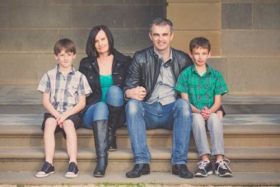PHOTO: Retired Major Anthony Krupa's PTSD developed following his many deployments, including to PNG and Iraq.(Supplied)
"I think the figures that we're seeing, which are alarming in themselves, are only the start of this."
The ADF's Joint Health Commander, Rear Admiral Robyn Walker, recently stated PTSD is not caused by military service.
It is a comment that has upset many, and Major Krupa says it is unhelpful.
"If this attitude is being said by our senior sirs and ma'ams, what hope do the young soldiers have?"
But Rear Admiral Walker says data shows there is no difference in the rate of PTSD in men and women who have deployed on operations and those that have not.
"There are some people who will develop it after one incident, but for many others it's actually a lifetime history of trauma," she said.
"And it might be that they had trauma - whether it be from a car accident, a physical assault, a sexual assault - prior to joining the ADF. It can be then built on by exposures in the military.
"People want to make it simple. Critics say we distance ourselves; that couldn't be further from the truth.
"What we're saying is that it's not a simple disorder that's just related to putting on a uniform and deploying to Afghanistan."

Lengthy compensation claims add to pressure
Mr Dobbs fears Australia's health care system is not ready for the deluge.
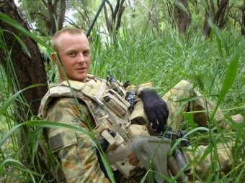PHOTO: Signalman Chad Dobbs on deployment in Afghanistan in 2009 (Supplied)
"At the moment, mental health cases in the public hospital system is overloaded. A lot of schizophrenic, a lot of dependency issues will take priority over this."
Others rage against the DVA. Compensation and pension claims can take a year to process, which can prove the last straw for those struggling mentally.
Mr Dobbs says a colleague killed himself this year when the system proved too much.
DVA mental health adviser Dr Stephanie Hodson says eligible veterans can receive treatment without filing claims.
"If you've got a diagnosis of depression, anxiety, PTSD or alcohol or other drug problems, we will organise treatment for you whether or not it was service-related."
DVA has a mental health website called At Ease.
"We want to give them some resources that allow them to take action themselves and we know from Beyond Blue ... that men prefer to take action than seek care," Dr Hodson said.
"Once people have had a chance to do some self-care, if that's not working, then you've got to have clear referral pathways. And there are a whole range of services."
And Rear Admiral Walker says the ADF is also improving access to treatment.
"We can use things like tele-psychiatry or e-health initiatives - you don't have to have the psychiatrist in the room.
"We've spent $95 million in the last four years on mental health support services in terms of health care providers, in terms of training, in terms of up-skilling our health care providers so they're better equipped to deal with PTSD in military personnel."
But Major General Cantwell says the demons confronting today's veterans deserve greater attention and funding.
"When one considers the $300 million-plus being spent on the Gallipoli centenary next year, a vitally important commemoration of an important part in our military and national history ... but ghee whizz, wouldn't it be great to see some of that money create an enduring effect for those veterans?"
Topics: defence-forces, mental-health, suicide, depression, defence-and-national-security, unrest-conflict

